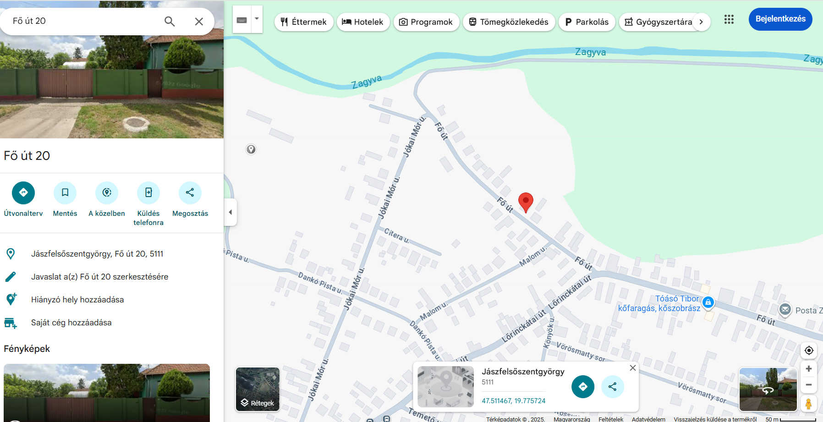

https://maps.app.goo.gl/eCgzsBSD6JyDWrLh9 GPS koordináta: 47.510819, 19.780874
