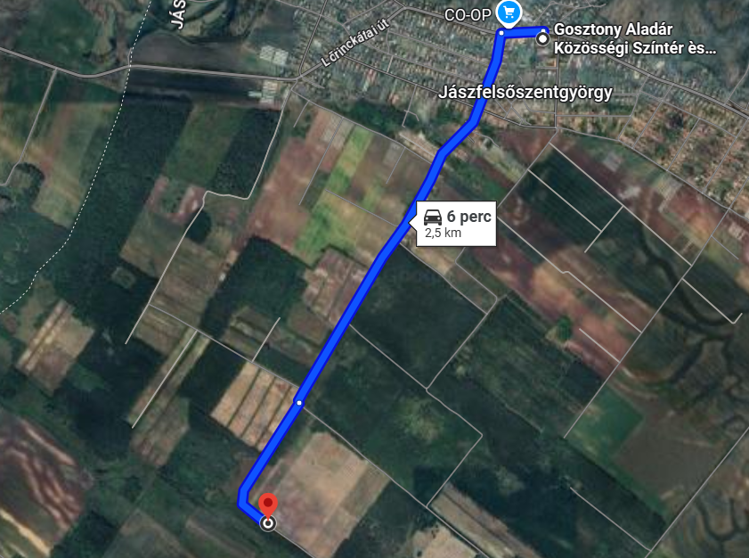

https://maps.app.goo.gl/4Q4wXkEStQ8pn6Uw6 GPS koordináta: 47.491548, 19.774634
